**Computer and Information System**

**CIS-4913 Capstone Project 1**

**Coursework Assessment1**

**202010_16985**

**Misbehavior and face detection in crowd using drone**

**Project Report**

**Project Mentor:** Dr.Shah.

**Client/ Organization:** Police.

Table of Contents

1. Abstract: 3

2. Introduction 3

1. Context 3

2. Motivation 4

3. problem statement 4

4. Project objectives or justification 4

5. project scope and stakeholders 5

3. Domain related Concepts and Systems 7

1. Introduction 7

2. Adopted Methodology 7

3. Study Feasibility 11

1. Technical Feasibility: 11

2. Operation feasibility: 12

3. Schedule feasibility 12

4. Economic feasibility: 12

4. Risk management 13

5. Requirements gathering 14

6. Conclusion 14

4. Computing-based Solution/System Analysis 15

1. Introduction: 15

2. Domain Requirement 15

3. Analysis Approach 17

4. Analysis 17

5. conclusion 23

5. Computing-based Solution/System Design, Implementation, and Test. 24

1. Introduction 24

2. Design 24

6. Development 27

3. Testing and Implementation: 34

4. Conclusion 34

7. Conclusion: 35

8. References: 36

# Abstract:

In 2020, there is a large population in the UAE and this lead to affect the security in UAE, for that, it is difficult for the police to detect the misbehavior person and arrest criminals in crowded places. Going through these activities will require time, resources and effort. Therefore, our proposed solution is to send a drone to the crowd area, take some photos and videos, then sends in real-time the recorded data to police. This data is then verified and analyzed and used for task’s estimation. To achieve this project, we went through the traditional approach phases. We use PM software to manage our project. starting with the project charter to identify the project tasks, scope, cost, and the project risk. Moreover, we collected the stakeholder requirement on the project plan using multi-technique and we managed the cost and the risk by calculating total cost and draw diagrams. Then, we start to clarify the project functionality in detail via different tools. After that, we start in the implementation by design a prototype, then we start coding; we explain the process in detail, including the code, pages. we close the initial part of capstone project 1 to give a reflection on the last part of the report on the previous phases.

# Introduction

## Context

In our current era, the UAE is based on technology in the high protection and efficiency in performance, especially in securing systems. So, in this project we're going to describes our efforts towards to improve process using drone for face detection system in order to overcome many of the limitations found in existing two-dimensional facial recognition systems. Specifically, this report addresses the problem of detecting faces.

Drones are aircraft that can perform autonomous pilot. They can easily reach locations that are too difficult to get or dangerous for human beings and collect images from bird's-eye view through aerial photography. Enabling drones to identify people on the ground is essential for various applications, such as surveillance, people search, and remote monitoring. Since faces are part of people's inherent identities, how drones can use well face recognition technologies becomes essential for future development.

In this paper, we conduct empirical studies to evaluate several factors that may influence the performance of face detection and recognition techniques on drones. “Face recognition is widespread in computer vision and can be viewed as a badge of success in image analysis and understanding.” (*University of Massachusetts, Amherst, October 2007)* Face recognition capability is undoubtedly a key for drones to identify specific individuals within a crowd. For example, to adopt drones in search of missing elderlies or children in the neighborhood, the drone’s first need to know who the targets are, and then the investigation can be launched.

Thus, face recognition on drones would be a vital technical component in such applications; consequently, face recognition on drones is a research topic worth investigating. The military use of drones has become the primary use of the day, and they are an integral part of military forces around the world. Drones will continue to be used in various military operations to reduce losses and enable them to carry out essential and time-sensitive missions. Many drones are designed exclusively for surveillance, while others are intended for offensive operations.

## Motivation

Drones were initially used for dedicated sometimes risky missions such as espionage, military attacks, rescue operations, monitoring, and enemies site exploration. Their use was rapidly expanded to cover many commercial areas including scientific, tourism, agriculture, policing, deliveries, and many other applications [4][5]. With advances in drones, hardware and software technologies including high-end cameras, face recognition, intelligent sensors, integrated GPS, autonomous navigation, longer battery, it becomes possible to implement very sophisticated and intelligent operations within the drone that can completely replace human and provide a high level of accuracy and efficiency.

In this direction, Fujairah police show a need to monitor the crowd area where it is part of the police tasks to detect any misconduct and inspect the damage, and with the limited number of police officers this process is usually required to international security, which may involve some other repetitions to verify the validity. This process lacks flexibility, is prone to error, time-consuming and requires frequent and communication between different stakeholders. The idea of automating this process while reducing human intervention, reducing time.

## problem statement

After our research, it became clear to us that the UAE is the first in the world in terms of security indicators, which reached a rate of 96.1%, and the indicators showed that the country leads in a decrease in rape, kidnapping, premeditated murder and the crime of theft from a means of transport. (AL Bayan news, 2019). We decided to maintain the country's index safety by using drone, especially in crowded and public places, using modern technology and the network will lead to reduce the police's budget and effort to provide protection and security in the general area.

## Project objectives or justification

The delivery of Misbehavior and Face Detection in Crowd using Drone system will add a high value to the institution, in addition to strengthening the monitoring system and supporting field operations and rapid intervention operations through the speed of data collection that will support officials, enhancing security, safety and safety for community members, as well as reducing the use of human cadres in police operations that depend on modern technologies and equipment.

The delivery of this project will add a high value to the Fujairah police:

* save 70% of effort and the time by increasing the efficiency and productivity of the work for police
* Supporting field operations and rapid response operations.
* Enhancing safety, security and safety for community members.
* search about misbehavior and remote monitoring crowd area.
* Provide extensive air coverage for the area.
* detect individuals within a crowd.
* Increase productivity and flexibility.
* Create a complete application that works effectively for police job.

## project scope and stakeholders

|  |  |
| --- | --- |
| Project Scope: | |
| Project Name | Misbehavior and face detection in crowd using drone |
| Project Sponsor | Police |
| Project Manager | Shah |
| Start Date | 9/9/2020 |
| Finish Date | 13/5/2021 |
| Estimated Budget | 10000AED |
| Description | The system will help police using drone: to monitor most public places from misbehavior and detect faces to ensure the compliance of criminals and their commitment to the law by tracking their movement, the idea is based on monitoring daily life in society to ensure faster and more accurate monitoring, better results, less effort, and providing evidence that can support problem solving |
| Constraint | The project must be finished within 9 months (2 semester) of starting  The project must not go over the budget  The application must be using network, and more secure  the drone must to have the required specifications |
| Assumption | The application will be available for all devices and all operating systems for the government.  It will be fast and highly reliable (with high security).  The users should be trained to use the system |

# Domain related Concepts and Systems

## Introduction

Information technology has become an essential part of our daily life. It has made continuous changes in all working methods and fields, as computer-based technology has become the primary means of transferring data. It is an essential gateway to many useful things such as in medicine, engineering, education and security. Therefore, in our project, we can provide the necessary protections for our country to protect it from corruption and uncivilized behavior through the work of an application that helps raise the performance of the Interior Ministry. In our project, we develop an IoT system application with using drone that works on face detection and recognize who is the misbehavior person in crowd area. The purpose is to reduce the effort of the polices on their field, manage and control the illegal behavior of any person on public by using more officinal of security to protect UAE society. The procedure will start with police officer will registration on the Fujairah government website and go to download the Misbehavior and face detection in crowd using drone application. After that, the police should login with their id number and password, then he has to pass the authentication process successfully then he accesses the drone dashboard.

## Adopted Methodology

Agile project management methodology helps us to be more flexible, reduce risks, improve productivity, create a revenue stream, reduce costs and ensures delivery of high-quality results before the deadline. We use it in our capstone project, to give us the liberty to make changes to the project requirements if we see difficulty also it lets us implement new changes at minimal cost. Also, it helps my team to bring constant improvements in every phase of the project. Agile methodology helps us in efficiently prioritizing tasks. If we have to make few changes, we can do it easily without wasting time due to flexible agile process. As we use an initial design for our project (prototype) we can had a stakeholder’s feedback to improve our solution.

The **steps we will follow in this methodology** are:

1. Collect the requirement by meeting the stakeholders and the clients.
2. Analysis of the data and the resources that we need in the project implementation.
3. Design the application and the website.
4. Write the code of the application and the website.
5. Test the application functions.
6. Maintenance is to check the service as the last step.

## Work Breakdown Structure (WBS) and WBS dictionary

We used in our project **WBS (Work Breakdown Structure)** to decompose the work into small tasks; it is a hierarchical graph execute by the team members to get done the objective and deliverables as it shows on the figures 1 below, and the directories on the figures 2,3,4.

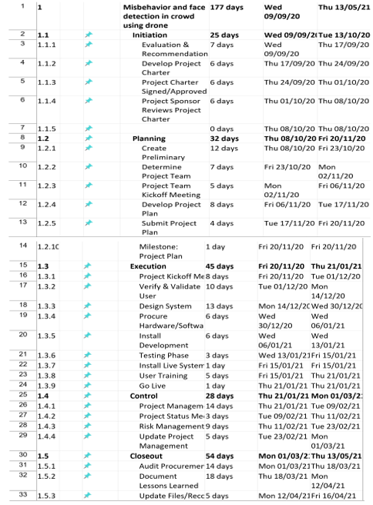

Figure 1WBS (Work Breakdown Structure)

WBS Dictionary (1)

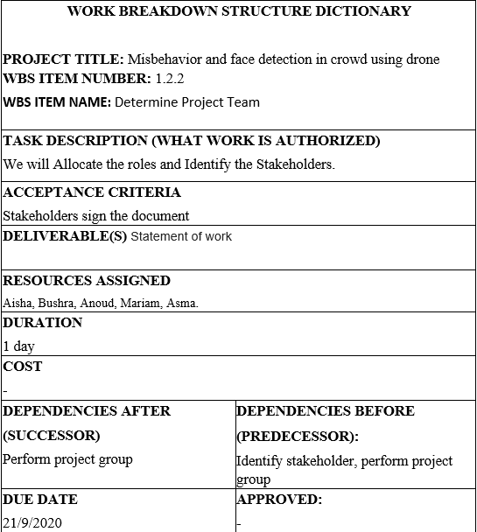

Figure 2 WBS Dictionary (1)

WBS Dictionary (2)

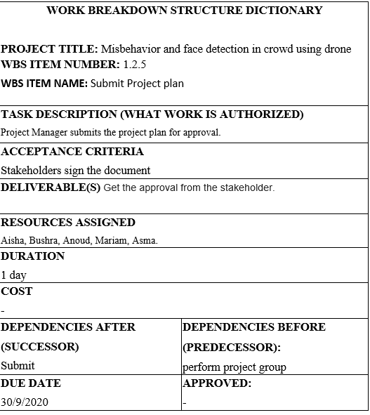

Figure 3 WBS Dictionary (2)

WBS Dictionary (3)

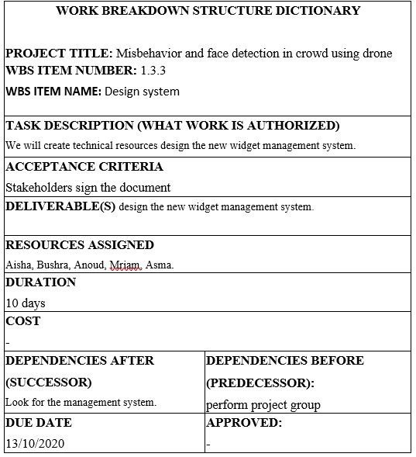

Figure 4 WBS Dictionary (2)

## Study Feasibility

### Technical Feasibility:

In the 21st century, the UAE has created full protection in all areas through intelligent security. And one of these methods is face detection. Our project will help to improve field of security for Ministry of Interior in monitor and controlling all the areas by using IoT networks. However, we will help UAE police by creating for them an application that controlling the drones on public and crowd areas to identify abusive or the lost person even if they in crowded place.

Our project will be different from other implemented projects as we will add more features such as a 3D camera and altitudes of drones keep them distant from their targets on the ground so, we will try to decrease the distance of the drone will reach as less than 500m. Considering the angle at which drones take pictures, this work will verify if face detection (or identity identification) is possible. The project work will also include developing multi-modal algorithm to try to identify a person or a misbehavior in the crowd.

### Operation feasibility:

This project will help reduce risks to people's lives and will also help police officer to speed up work-process. The function of this technology is depending on IoT and implement an application that will helps controlling and monitoring the crowded area. Our project will be little bit expensive because the equipment is expensive but looking at other projects, the needs of devices used on prevent abusive behavior in one system is 100 fixed cameras and its controlling by a big controlling room. So, we replace them with a flexible camera in the drone which we monitoring by one device. The project will depend on drone to monitor the area, record videos, and take photos, then videos and photos will be analyzed and processed through a secured system. Moreover, our project idea will increase the efficiency and performance of the security system and will facilitate the efforts of the employees in the performance of their functions and get good results in simple way.

### Schedule feasibility

Schedule feasibility study helps to identify the various constraints on the project schedule and it helps us to do the project orderly and clearly. For that, the project must be finished within 9 months (2 semester) of starting. We start our project from 09/09/2020 and the deadline 13/05/2021.And we use a project management software (PWS) to mange our time for each phase.

### Economic feasibility:

When we were planning for our project, we decide that our initial budget is 80,000 AED for all resources of employee, hardware and software. Also, we decide to be adhered to the financial budget. So, when we start working on design and implement our project we seen that we will not going over the budget, we will spend approximately 66,315 AED.

## Risk management

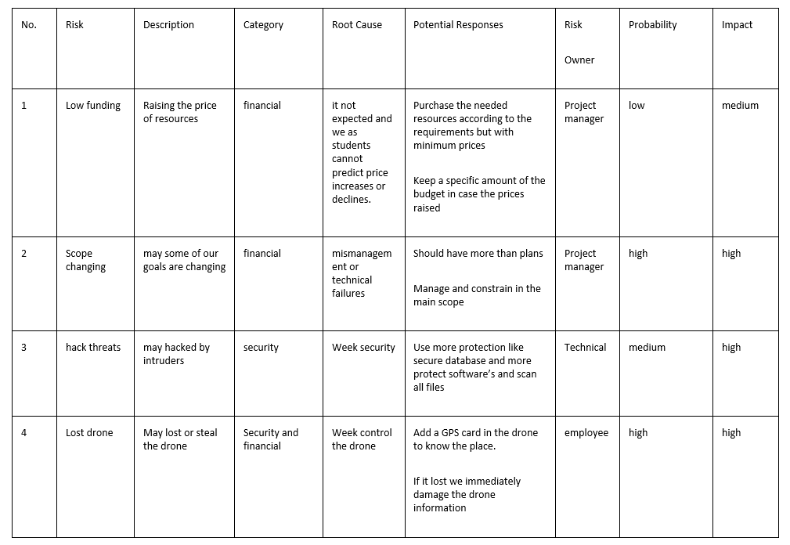

## Requirements gathering

We collect information to identify Fujairah police officer problems and needs. We have conducted some formal interviews to get some information about the difficulty in searching for misbehaviour in crowded places, how to solve their problems using the drone in their work, and what are the ways that can help the police to be more comfortable to identify the face of misbehaviour person. As mentioned, there are some problems related to police work on this field without using drone and IoT such as: it is possible for police to reach locations that are too difficult to get or dangerous for human beings and collect images from bird's-eye view through aerial photography. Since faces are part of people's inherent identities, police can use some tools to help them to improve their work and reduce time takes to be done.One of the police also said that they take a lot of effort and wasting time in recognize misbehaviour and monitoring crowded area because the movement in the crowded area are very difficult and some time they cannot be sure about face detection, so they wish that there is a useful technology like a drone to achieve their work in good way.

Also, we have identified some problems through our observations, such as the problem that we may can’t catch the misbehaviour person in crowd area if they hiding their face by any materials like mask. There was an incident in crowd mall where someone says that he was embarrassed to be caught by mistake by the police in a public place, where he was wearing a mask, and they removed quickly. Then, they apologized to me and said suspicion. (Bhattacharya, 2016)

We designed the Misbehavior and Face Detection in Crowd using Droneto solve all the problems that may face the polices in crowd places to know precisely who and where is the illegal behaviour. We've identified a lot of things like requirements, limitations, scope, costs, and risks. What is worth noting here is that gathering information is the most critical task we need to do before starting any project. It helps us identify police needs and requirements and identify problems and issues that we need to resolve. In the end, the project we have done is to help people to have a save life.

## Conclusion

In our application, the problem is that we are trying to help and reduce the effort of police in detecting misbehavior people in crowd, while using drone system is effective and will solve the problem. We’ll use JavaScript programming language, it’s difficult for us because we have not studied for a lot, we solved this problem by asked help from people with experience and we searched for the necessary codes. Also, connecting devices is difficult for us because it’s the first time we use drone and we don’t which tool we have to choose.

The challenges we might face, such as time constraints to create a complete plan for our project that will works within a few months, we have made plan to address this challenge by managing time to finish the project at the time and also using a new language in programming that we have not learned enough was another challenge, but we're planning to have our programmer guide to get help while we're still gathering more information.

# Computing-based Solution/System Analysis

## Introduction:

analysis it’s the important part in all implementation of new project used to identify the necessary improvements needed in the project plan by looking at different processes and determines what can be done to make them better and more effective. The process analysis looks at the process improvement from both the technical and organizational standpoint which is in deep details; we will explain the steps of the analysis phase, considering the benefit from the phase to determine the client's needs (police) with understanding what the process requires. In additional, it’s used to be aware how to connect and control the drone and how to use the application and the website in a simple way. Moreover, using the SDLC -Agile model as a methodology to follow in our project to develop our application which will be a useful tool for police officer by using flexible technology which is drone. Therefore, by defining the phases we will follow in our project, it’ll start with project planning, analysis, design, implementation, and maintenance. In the analysis, using diagrams that can raise the understanding of the system requirements and can help us look into the current plan for the project as well as the ways on how these plans will be implemented.

This application runs through Node-RED programming tool and Watson Visual Recognition nodes in IBM Cloud. Node-RED is a programming tool that you can create your own application by dragging the node from your color palette onto the workspace and start connecting them together, it connects devices and APIs across the Internet. That’s why we chose it because it is the language that suits our requirements. We have chosen Watson Visual Recognition because he has several advantages such as creating custom unique visual classifiers, analyzing images for scenes, objects, and other things and develop applications that analyze the visual content of images or video frames to understand what is occurrence in a scene. And for the drone that we'll be using is the Tello Drone for many reasons, the Tello combines industry-leading technology and entertainment in an easy-to-use drone. Due to its compact size, the Tello is easy to take anywhere and easy to use in any circumstance and it can fly for several minutes in a row and at the same time shoot with a resolution of 5 megapixels.

## Domain Requirement

This section defines the services and functions that will be provided by our system. These requirements are divided into functional and non-functional requirements; the following are the functional requirements of our system. figure show our system overview

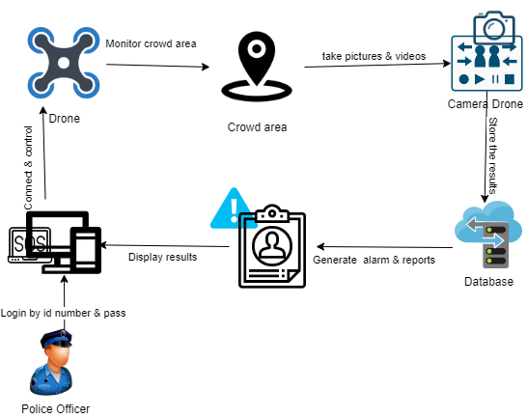

Figure 5 system overview

* **Functional Requirements**
* The system must enable users to do
* Access to the control panel.
* Entry permit by authorized police id and password.
* Connecting and controlling drone.
* Go over the data taken by the drone.
* View a real-time video from the drone.
* Carry out things when necessary.
* Assign mission.
* Entering all database.
* Generating and describe alarm.
* check and edit the final report.
* The system must allow the drone:
* to take photos and videos of misbehavior in crowd place.
* Detect and recognize faces
* Monitor crowd area
* Send alarm
* **Non-Functional Requirements**
* **The system shall operate 24/7**
* **The system shall have an easy to use interface**
* **The system shall have a pleasant appearance**
* **The system shall be secure enough when handling any data entry**
* **The system shall be accessed using smart devices or laptop or computer**
* **The system shall display the final report of the results.**

## Analysis Approach

The Object-Oriented (O-O) approach analysis used to reduced maintenance, code reusability, real world modelling, and improved reliability and flexibility. The program of this approach is to organized by having number of classes and objects. The aim of the analysis approach is to study the system, and the problems to determine the changes that must be made to achieve the project in an easier and faster way. We used online tool like Draw.io to create different type of diagrams, it is an effective and efficient tool that contains many elements, shapes and styles. The diagrams help our team to be more strategic and on point of planning. Moreover, the diagrams must be complete, organized, and well-formatted.

* **Use case diagram** summarizes the details of system's users (known as actors) and their interactions with the system.
* **Use case descriptions** describes the use case goal and gives a general description of what usually happens, the normal course of events.
* **System sequence diagrams** use it to illustrate how certain tasks are done between entities and the system in sequence
* **Activity diagrams** presenting a series of actions in a system in flow. also describe the steps one to another by using getaways and events sign
* **Domain class diagram** shows the conceptual model of a domain of interest, the attributes it possessed and the relationships between entities

## Analysis

UML Use Case Diagram

The use case diagram helps us understand how a police officer, drone and database entity might interact with our system. And it helps our team define and organize requirements. The use case diagram has different types of relationships between entities and process (functions) such as include, extends, association, generalization, and dependency. For our use case diagrams, we used only include and extend relationships. Figure 1 represents the use case diagram.

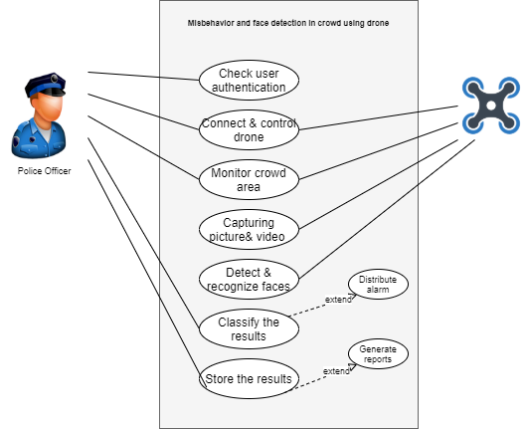

Figure 6 use case diagram

Use case Description

We have also generated the use case description for a few and the most important function in our project as shown below. It describes the function in details includes: who are the participating actors, description existing relationships, what triggers of the function, and the alternatives if there is any.

Use case Description (1)

|  |  |
| --- | --- |
| Use Case Name | Check user authentications |
| Participating  Actors | Police Officer |
| Description | This use case describes how to authenticate the user by checking the police ID and password. |
| Trigger | The police must enter the police ID and password |
| Relationships | No relationship |
| Flow of Events | 1. Police Officer enters his ID. 2. Police Officer enters his password. 3. The system will check the validity of the police ID and password and if they match. 4. system display message accessing done |
| Alternative  Flows | 1a. Entering wrong password  3a. ID or the password is not valid, the system will give the user an error message to try to enter a valid password  4a. System crash |

Use Case Description (2)

|  |  |
| --- | --- |
| Use Case  Name | Connect & control to Drone |
| Participating  Actors | Police Officer, Drone |
| Description | This use case describes how the user connect and control the drone to the system through a Wi-Fi connection and let them fly and assign a mission |
| Trigger | The user must turn the Wi-Fi on to be able to connect the drone and must enter control panel to effect drone movements. |
| Relationships | No relationship |
| Flow of  Events | 1. The police connect the drone to the Wi-Fi 2. The police connect the system devices to the internet with an Ethernet cable 3. The police enter the control panel 4. The police control the drone manually with buttons 5. The drone automatically will be connected to the system |
| Alternative  Flows | 1a. Cannot interact with Wi-Fi.  2a. Damaging Ethernet cable.  4a. Cannot control or connect to the drone. |

Use Case Description (3)

|  |  |
| --- | --- |
| Use Case Name | Identify the Face |
| Participating  Actors | Police officer, Drone |
| Description | This use case describes how the police will detect the face and the drone will recognize the face of misbehavior in the crowded area |
| Trigger | The police must enter the police must enter face detection and send the mission to the drone and the drone able to recognize the misbehavior person |
| Relationships | No relationship |
| Flow of Events | 1. The police enter the face detection 2. The police send mission to the drone 3. The drone receives the face detection 4. The drone recognizes the misbehavior |
| Alternative  Flows | 3a. Drone doesn’t receive any detection information  4a. Drone not found the misbehavior. |

Use Case Description (4)

|  |  |
| --- | --- |
| Use Case Name | Storing the results |
| Participating Actors | Database |
| Description | This use case describes how the database stores the information and the police officer can retrieve the results by generating report |
| Trigger | Taking picture and video + Result generated |
| Relationships | Extend Relationships:  Storing the results may retrieve again and again to police officer which should be extended to generate reports. |
| Flow of Events | 1. Each taken picture and video will be stored in the database of the system in different categories 2. The database of the system will store the results of each picture and video description. 3. The database of the system will generate report. 4. The police will send and receive the results. |
| Alternative  Flows | 2a. The database full of data  4a. The data of results are deleted |

System Sequence Diagram

Using system sequence diagrams to illustrate how certain tasks are done between entities and the system in sequence. Figure 2 represents the system sequence diagram for the whole system

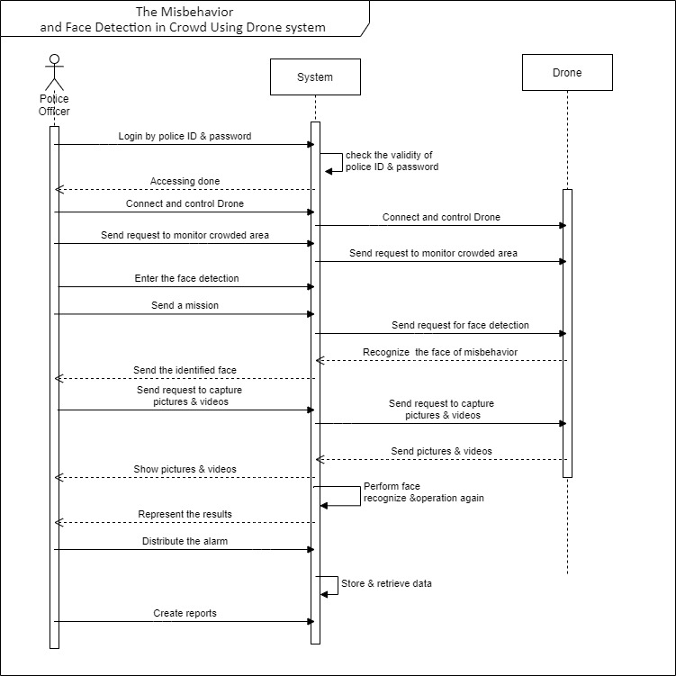

Figure 7 system sequence diagram

Activity Diagram

The activity diagram is presenting a series of actions in a system in flow. also describe the steps one to another by using getaways and events sign. We use two getaways sign which is parallel and exclusive getaway. Figure 3 represents the activity diagram for the whole system.

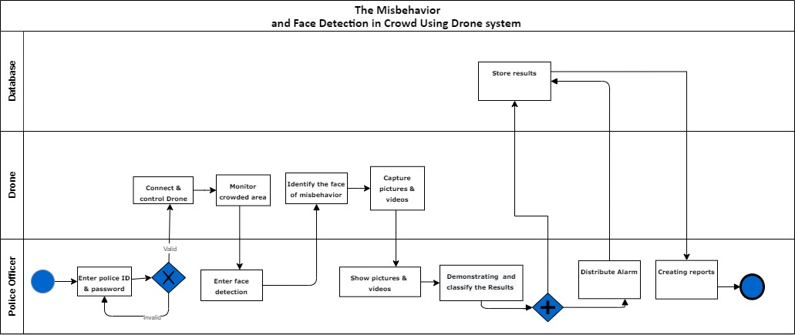

Figure 8 Activity Diagram

Entity Relationship Diagram (ERD)- Physical Data Model

In our system, we used ERD to create the database tables and the relationship between them. The physical data model is the most detailed data model in this process. For that, each drone can take many pictures and videos, and each of them can be made by one drone. Each pictures and videos can have only one evaluation, and each evaluation belongs to only one pictures and videos. The drone can have many faces detection function, and each face detection can be assigned to many drones. One police may fly many drones, many drones controlled by only one police. Police may generate many alarms, and an alarm can be generated by only one police. one alarm can have only one database, only one database can store only from one alarm. Figure 9 represents the ERD.

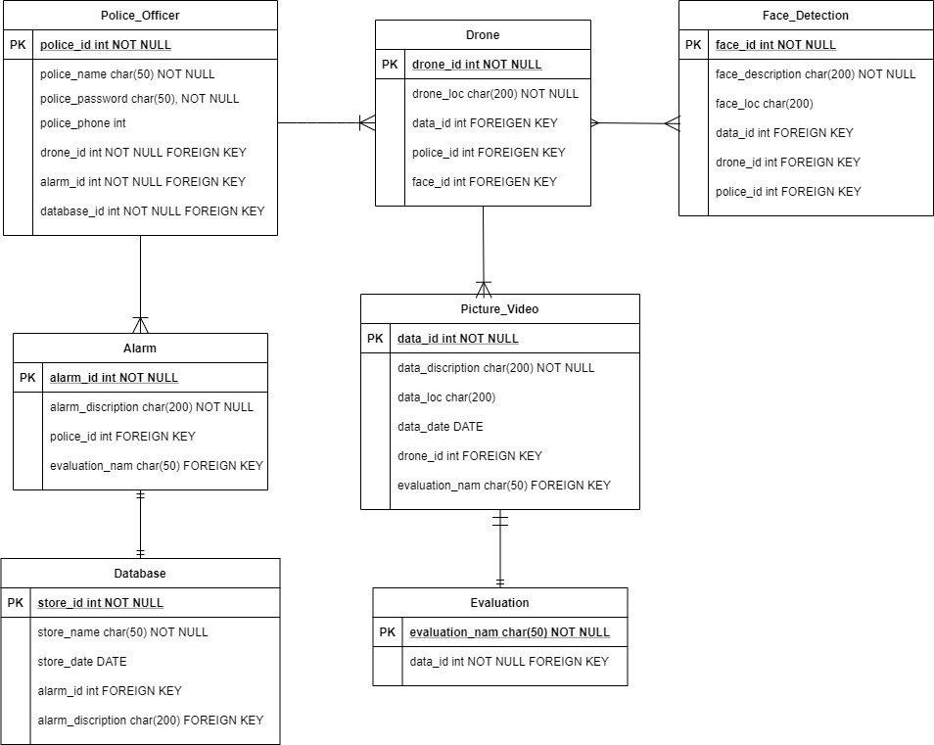

Figure 9 ER DIAGRAM

## conclusion

Finally, our project will be the drone will help in saving the operating cost and at the same time protect the personnel, thus this will help reduce illegal activities and help solve problems and maintain security stability across the country. There is a growing interest in developing these drones.

In the analysis, we made diagrams with the client(police) who will get benefit from our project on the basis of his needs. There are also technical areas that team members need to learn about, for example, technical writing and programming technique. Moreover, we face difficulties in some parts of the analysis project. For example, wasn’t easy to know more about approaches and different type of methodologies to choose what is best for our application project. Also, it was a challenge for us to build many diagrams that contain many details in a professional way. Where the major challenge we faced that we had many complications in making diagrams. Firstly, we searched more about how to do the diagrams in the analysis phase Secondly, manage our time to complete this phase in the given time. In the end, every challenge teaches us new skills and knowledge we are glad to gain it.

# Computing-based Solution/System Design, Implementation, and Test.

## Introduction

Misbehavior and face detection in crowd using drone system is a significant addition to security and protection applications for ministry of interior, where security is a major concern. Therefore, we are focused on secure crowd area with more protection to reduce risks and misbehavior. Also, police will have the ability to quickly connect and control the drone. Our objectives for this project are to create a complete application that works effectively to maintain and support security, protect society, face detection. As well, reduce the rate of the effort of police officer around the country.

## Design

The Designing phase will help us in the implementation phase by defining the main things according to the earlier stages. It is important that the proposed design be tested for performance, and to ensure that it meets the requirements outlined during the analysis phase. Our project used the Data Flow-Oriented Design approach (Structured Design) to describes the flow of data through a system to perform certain system functions. DFD describes the processes involved in a scheme to transfer data from the input to the file storage and report generation. The physical data flow diagram represents the implementation of the logical data flow.

* The Database

Based on the Entity-Relationship Diagram, we design the database to store specific information. The entity relationship (ER) data model is well suited to data modeling for use with databases because it is relatively abstract and easy to discuss and explain. ER models are readily translated to relations. ER models, also called an ER schema, are represented by ER diagrams. ER modeling is based on two concepts: entities and relationships, defined as the associations or interactions between entities.

Types of entity's relationship to design the type and kind of information that will be stored in the database and retrieved from the database.

1. ID number and password will be retrieved from the database to ensure user authentication.

2. Drone Information will be stored in the database.

3. Information about (face detection and recognize).

4.Rcording data (pictures, videos and info about the area).

5. Mission information will be adding from the system storing in the database.

6. Analysis results will be shown in the system dashboard and stored in the database.

7. An alarm will be generated from the system and saved in the database.

8. Collecting reports from the system to the database

* The Network

There will be a connection between the entities of our project: police officer, drone, system, and the database. The system will control the drone, the drone will send information to the system, the police officer will analyze a retrieve the results with the system, and the database will receive data and information from the system. This communication type allows us to choose the network based on the required security level. It may also include cellular communications, which rely on 3 GHz, 4 GHz, 4G+ (LTE), and 5 GHz. It is essential to secure such wireless communications networks when being used. Also, drone should connect with the device because GPS tracking communicates location back to your control so that you know precisely where your drone is at all times.

* Design the screens

Based on the analysis phase, we designed the system's screens and pages using the JustInMind are an authoring tool for web and mobile app prototypes and high-fidelity website wireframes. It offers capabilities typically found in diagramming tools, like drag and drop placement, re-sizing, formatting, and export/import of widgets. Also, it has features for annotating widgets and defining interactions such as linking, animations, conditional linking, calculations, simulating tab controls, show/hide elements, and database simulation with real data that prototyping tool to contain all the functions and address all inputs and outputs.

* Human interface - User interface design:

To start function our system, first the police should go to Fujairah government and select the connect drone button to start to connect and controlling the drone. Second, it will go to authentication page where the police will enter his id number and password then click login button. If the entering information correct it will send them to selection drone page if its not correct it will enter again. In selection drone page, police officer should select which drone he need and if he wants to see the drone information such as: speed, battery and more in telemetry page before he connects to chosen drone. Then he will go to search and monitor crowd area in map page, when he will select next button he will go to mission page where the he should add mission name and the date and time. To start the mission the police should click on start recording to go to next page. The next page is choosing the method to start mission even by going to recognize button that will let them to go to the database of face detection file page. In face detection file page, police should select one of the faces that the drone should detected then select next to go to control panel or he can go immediately to searching button to go to control panel for drone page. In this page, police can control the drone directly and the movements, if the police didn’t find any misbehavior in the crowd he will end the mission and if he found he will click on alarm button. When he selects it well send alarm information, he will classify the results then he will call SOS. The SOS button will generate emergency alarm massage to all nearly polices to catch the problem. The final function he should do is to store his mission information in the database system and he can generate a report.

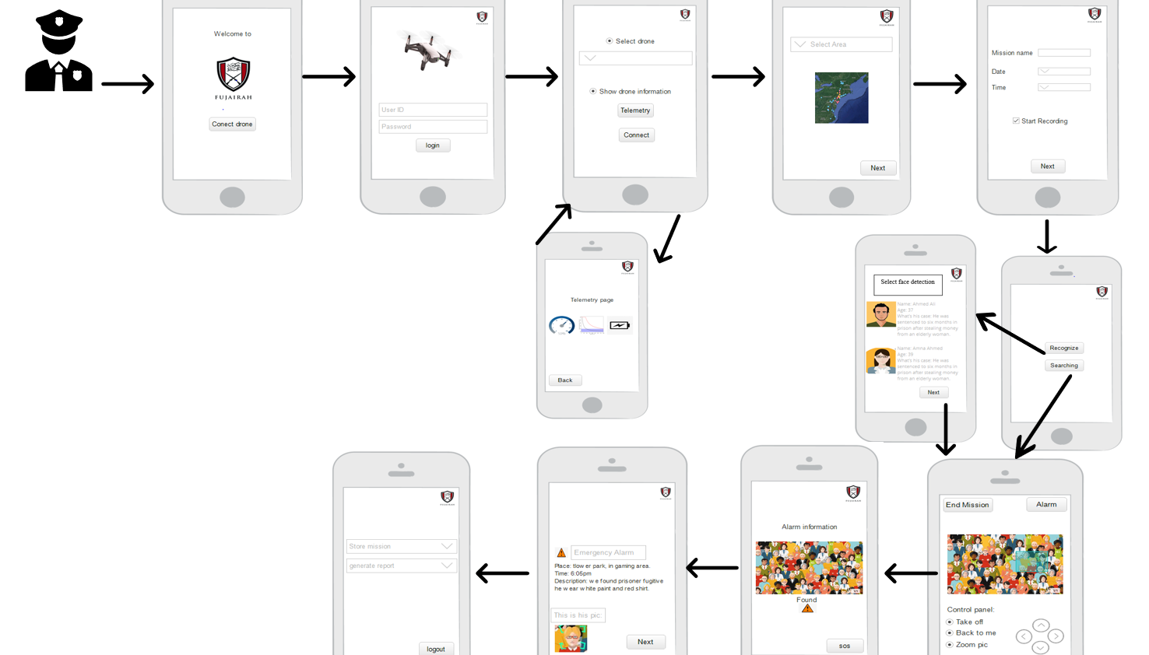

Figure 10 shows an Initial form of the application

# Development

In the improvement stage, we gathered all the outcomes and the yield from prior stages to execute the undertaking. We purchased a Tello drone with an implicit camera and sensors, as we chose previously. We downloaded the Node Red programming device locally on our PCs and smart devices. Our drone will also be included face detection and recognition in crowded area and monitor crowded area.

Also, from this progression, the programming level has been begun. A verified client must access the Node-Red editorial manager with a substantial username and secret word. At that point, the drone must be associated with the PC or smart devices through a Wi-Fi association. From that point forward, the client will begin another mission by entering mission subtleties in the framework, and the mission subtleties will be put away straightforwardly in the Cloud-ant information base. The framework will control the drone, and the framework will get pictures from the drone. Pictures will be dissected naturally utilizing Watson Visual Recognition from IBM Cloud, and alerts can be produced for dubious circumstances. All the outcomes will be spared in the Cloud-ant information base, and an HTML report will be created and spared consequently in the PC or smart devices.

Node-RED emanates from an open enterprise, created by IBM, proposing a flow-based and event-driven programming device. The application's conduct is in this manner spoke to as an organization of black-boxes, which may speak with one another and direct the progression of the data inside the planned framework. A visual browser-based portrayal upholds creators and engineers in better thoughtful the incident collaborations inside the entire IoT network. Indeed, numerous substances might be included, both equipment (eg, sensors) and programming (eg, administrations). Node-RED additionally empowers the genuine association of equipment gadgets and application programming interfaces (APIs).

Since Node-RED permits the integration of diverse advances, much appreciated to appropriate libraries, the taking after ones have been embraced within the displayed arrangement:

* MongoDB, as a database motor, rather than a social database, due to its more noteworthy effectiveness in reacting to an expansive number of inquiries in a brief time.
* Java as a programming dialect, due to its broad selection in genuine executions.
* Message line telemetry transport (MQTT), as a lightweight, distribute and subscribe strategy, for data sharing and system's notices. Note that Node-RED is mindful of controlling the data flow and for giving the rationale of the total IoT application.
* Programming Language

This application runs through Node-RED programming tool and Watson Visual Recognition nodes in IBM Cloud. Node-RED is a programming tool that you can create your own application by dragging the node from your color palette onto the workspace and start connecting them together, it connects devices and APIs across the Internet. That’s why we chose it because it is the language that suits our requirements. We have chosen Watson Visual Recognition because he has several advantages such as creating custom unique visual classifiers, analyzing images for scenes, objects, and other things and develop applications that analyze the visual content of images or video frames to understand what is occurrence in a scene. We chose this time for our undertaking to utilize the Node-Red programming instrument. Hub Red is an open-source and free programming instrument used to associate equipment gadgets, APIs, and other online administrations. Since we are building an Internet of Things framework, we thought that it was simpler for us to utilize it to interface the drone to the framework. It is a program-based supervisor; we can undoubtedly alter and interface streams which are spoken to as hubs and afterward send the progressions to run it with a single tick. Hub Red is based on Node.js, which executes JavaScript codes. The streams are put away in JSON design, which makes it simple to import and fare the orders (Node-RED).

In spite of the way that you could express that Node-RED is such a visual programming language, I feel that it isn't equivalent to various vernaculars of a comparable kind as a result of its balance. While standing out it from various tongues, the congruity among comfort and helpfulness is commonly fantastic. For example, there is a data stream coordination instrument for specialists in a comparative class of visual programming language. This moreover uses a web interface where you can distribute fights and partner them with lines to robotize dataflows between systems. Regardless, when you truly endeavor it, it is extremely difficult to use. Having an abundance of limits, it requires settings that are troubling regardless, for specialists, and it is much of the time hard to use for people who are not capable designers. On the other hand, Node-RED has a fundamental web interface and has another look. Similarly, you can make complex activities with incredible straightforwardness. The amicability between these two segments is prominent.

* Database

We are utilizing the IBM Cloud-ant database for our venture; it offers the database as a benefit and employs Apache CouchDB. It is as it were accessible online and employments the Erlang dialect that can be gotten to through Relaxing HTTP/JSON API. The database permits information strength to form information tireless and give get to control (Framework Properties Comparison Cloud-ant vs. Couchbase vs. CouchDB, n.d.)

* Network Configuration

To associate the robot with the framework, we utilized a Wi-Fi web association. We likewise expected to associate the PC to the web in which the hub red is introduced on it locally, with an ethernet link to try not to lose the association with the robot, since it is difficult to interface a PC with two diverse remote associations simultaneously.

* Other Development Tool

We utilized the IBM Watson Visual Recognition administration to let our framework comprehend the substance of each image as the human does. Watson decides whether the substance of an image coordinates a labeled picture. With Custom Object Detection Feature, Watson can distinguish objects in an image, and dependent on this ID; it gives us criticism as a level of picture precision (Khan, 2019).

* Codes
* Node Red Commands

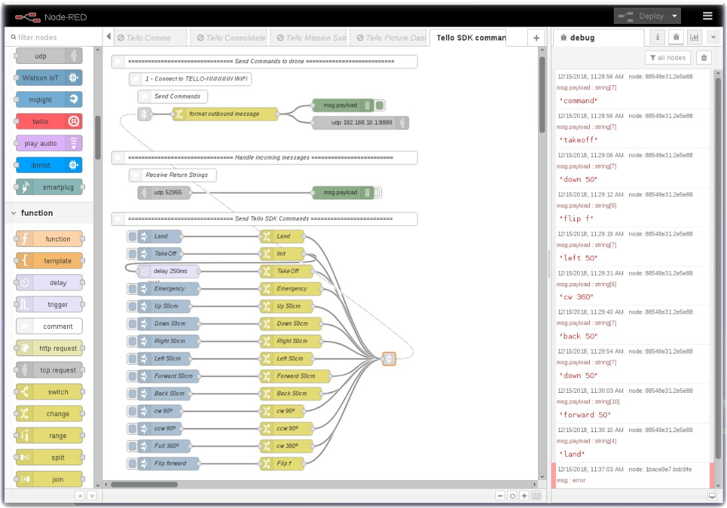Here is a screenshot for pages codes, the codes files attached with the report 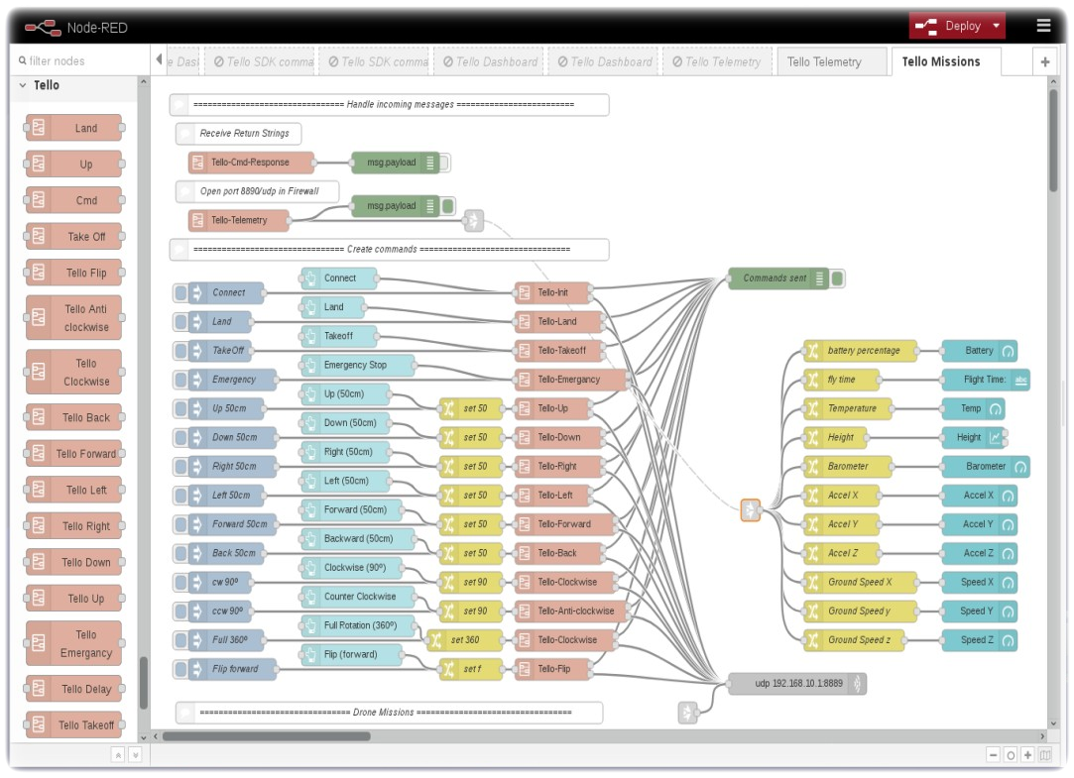

Figure 11 Mission Code Page

Figure 12 Dashboard Code Page

* **Node-red-detection-face-recognition:**

This node aims to wrap the epic Face-API.js library from just dude who hacks into a simple to import and use node in Node-Red.

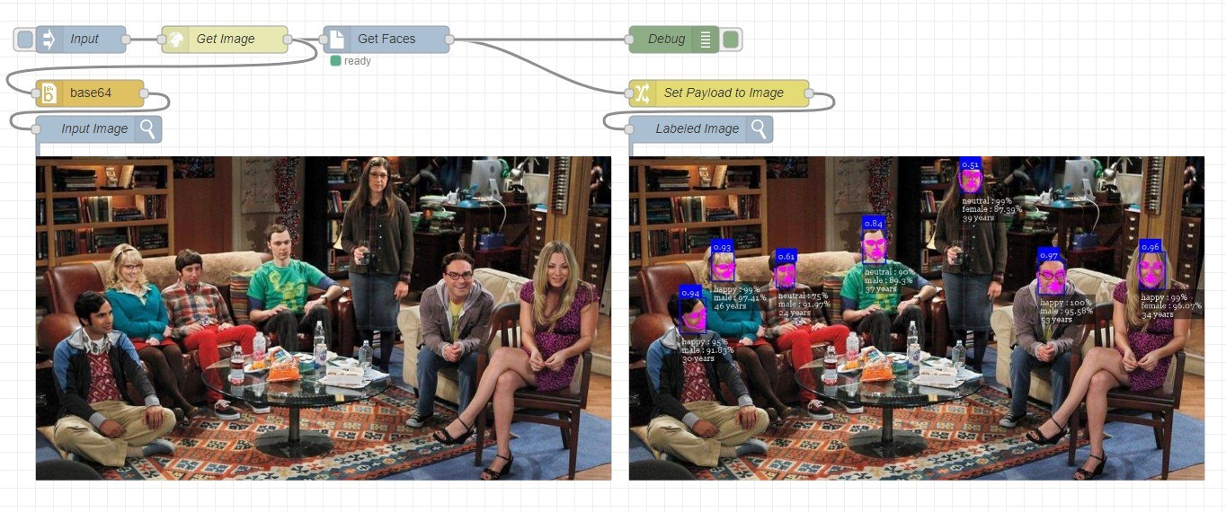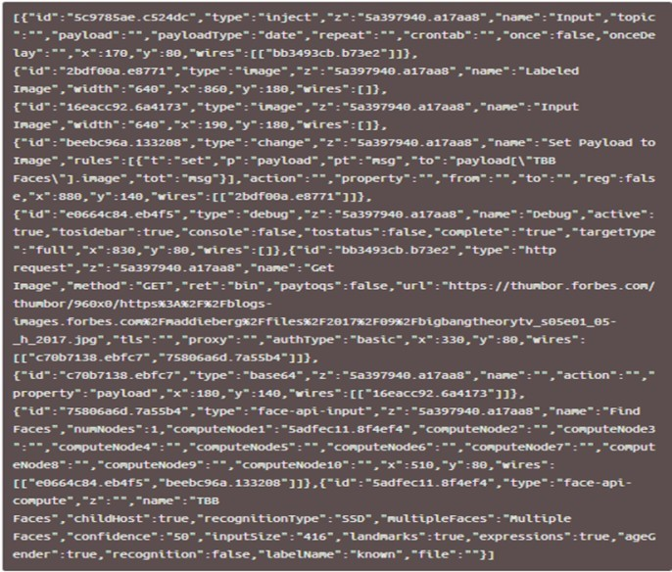

Figure 13 face-recognition code page

## 

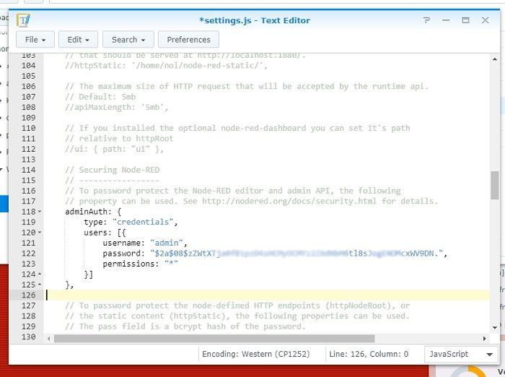

Figure 14 Setting File

* IMB Cloud Service

We create three services in IBM Cloud: Visual Recognition, Watson Studio, and Cloud-ant database.

* Virtual Recognition:

It’s more secure, its database is larger, in addition to improving and correcting the tasks that you do, and artificial intelligence provides completely new ways to complete data. Also, it analyzes the pictures and video which is recorded the data to give approximate proportions of what the picture contains and if they identify and recognize that is mass behavior.

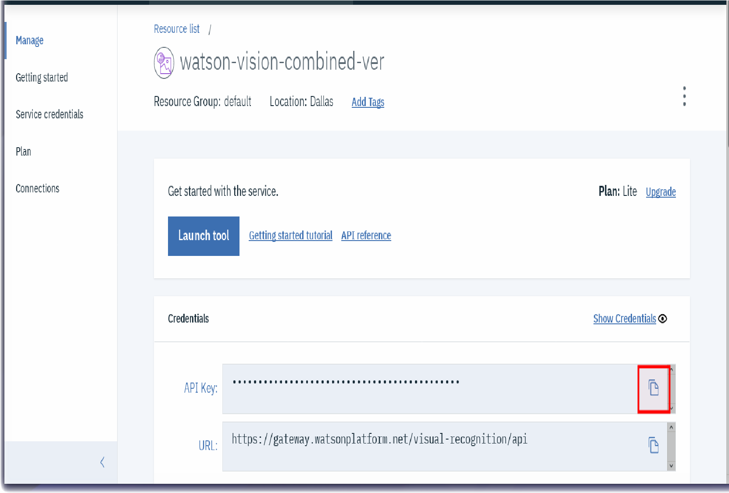

Figure 15 Virtual Recognition

* Watson Studio

Since your Tello drone is recording, taking pictures and collating pictures using the virtual classifier, recording videos and photos and also searching with face detection technology, we must have a Tello drone; take pictures, tag photos with a custom workbook.

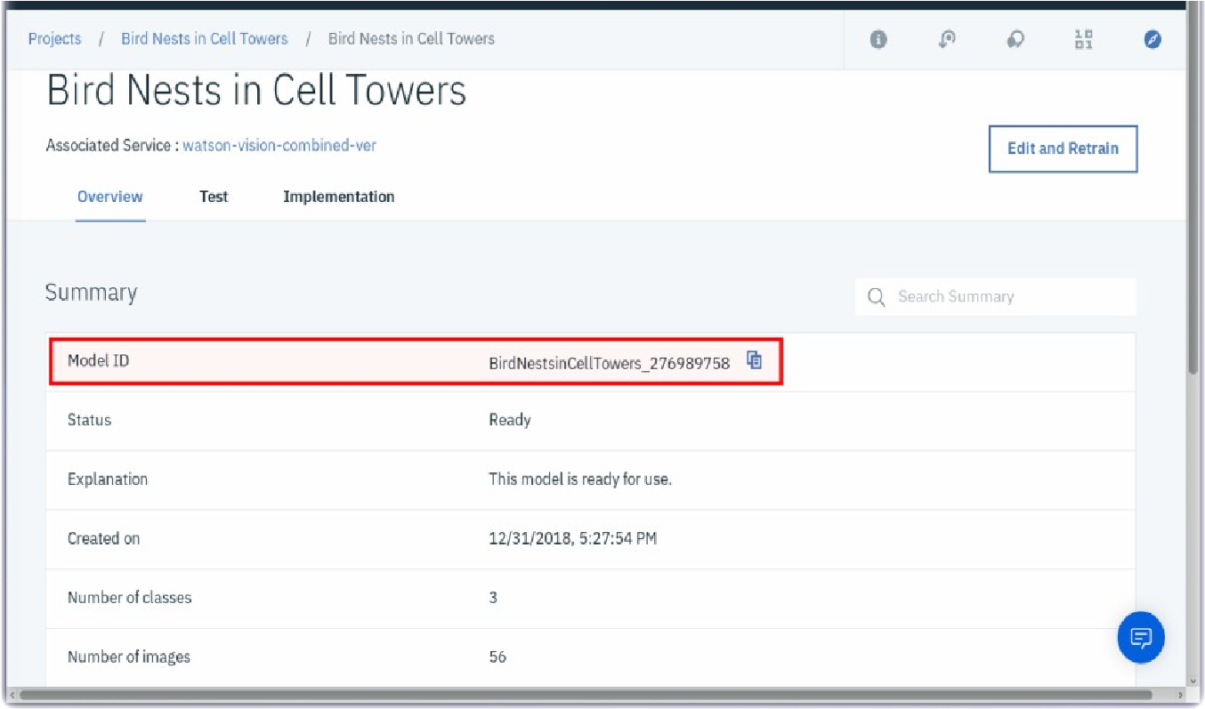

Figure 16 Watson Studio

* Cloud-ant Database:

Information such as important information and face search results, captured video recordings, photos and alerts saved from the system to the database.

Cloud-ant result:

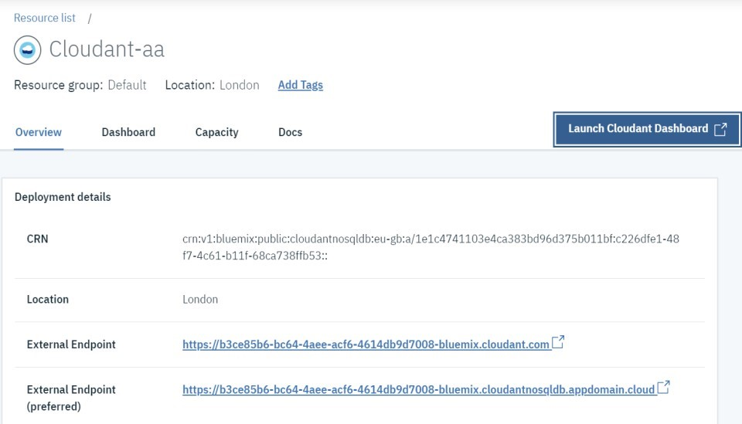

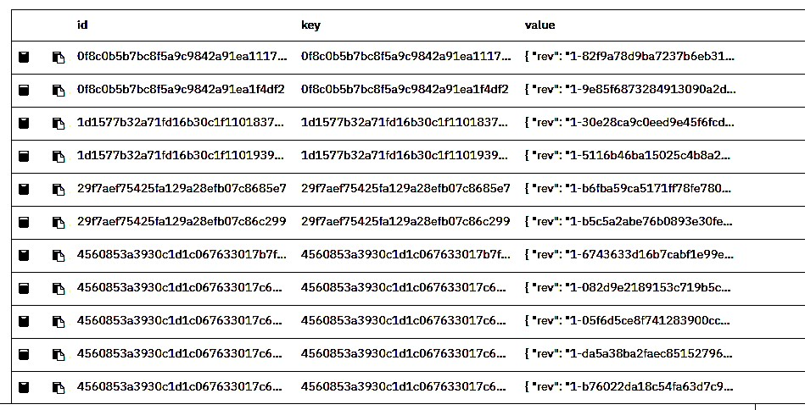

## Testing and Implementation:

After completing our system, it is important to test it to check if the functions are functioning properly, the ability to add inputs correctly, obtain correct output, and to check whether the system meets our specifications without any bugs. For that, we make an initial configuration and implementing that show a small function of our project and in next semester we will have a complete implementation of our project by buying a drone and we should test it.

## Conclusion

Finally, we finish from the last steps in the project management life cycle before closing phase. We work on analyses requirement by using design materials which describe how our system work and how its look and then start with the implementation phase where the users test the system and interact with the system. We created an early prototype which is useful to understand how the system will look like and how it will ready to go live for that, the design phases were simply, and we finished it within few problems and in implementation phases was complex and take a lot of time. We faced many challenges as: we are learning how to use the Node-Red, we spent a lot of time because we go step by step and discover all the tools , we tried to connect our system with Cloud-ant database and we face some difficulty and we can’t change our choice because it was the most compatible with Node-Red and our requirements and choosing a simplest and familiar code language take some time also run it if its work.

Through design and implementation our system, we discovered and learn several categories of technologies which is belong to IoT. We learn that we have to work hard, challenge our self to solve what required from us. Like, in our project we work in different online tools which help us to design and implement it and these decisions were helping us in have improved our skills in learning, researching, time management, and making decisions.

# Conclusion:

# References:

1. N. Shachtman. Army Tracking Plan: Drones That Never Forget a Face, <http://www.wired.com/2011/09/drones-never-forget-a-face/>.
2. Albayan news - Dubai <https://www.albayan.ae/across-the-uae/news-and-reports/2019-03-18-1.3514646>
3. Emirates Face Recognition http://facerecognition.ae/CompanyDetails/7GÄ…szczak, T. P.Breckona, and J. Hana. Real-time People and Vehicle Detection from UAV Imagery. In IS&T/SPIE Electronic Imaging, pages 78780B-1-13, 2011.
4. APM. APM Autopilot Suite, http://ardupilot.com/.
5. F. Nex and F. Remondino. UAV for 3D mapping applications: a review. Applied Geomatics, 6(1):1-15, March 2014.
6. G. B. Huang, M. Ramesh and T. Berg and E. Learned-Miller. Labeled Faces in the Wild: A Database for Studying Face Recognition in Unconstrained Environments. Technical Report 07-49, University of Massachusetts, Amherst, October 2007.
7. GoPro, Inc. GoPro, http://gopro.com.
8. International Civil Aviation Organization. CIR328 AN/190 Unmanned Aircraft Systems (UAS), 2011.
9. Ira Kemelmacher-Shlizerman, Ronen Basri. 3D Face Reconstruction from a Single Image Using a Single Reference Face Shape. IEEE Transactions on Pattern Analysis and Machine Intelligence, 33(2):394-405, 2011.
10. Itseez. OpenCV, http://opencv.org/.
11. J. Paneque-GÃ¡lvez, M. K. McCall, B. M. Napoletano S. A. Wich, and L. P. Koh. Small Drones for Community-Based Forest Monitoring: An Assessment of Their Feasibility and Potential in Tropical Areas. Forests, 5(6):1481-1507, 2014.
12. P. Korshunov and W. T. Ooi. Video quality for face detection, recognition, and tracking. ACM Trans. Multimedia Comput. Commun. Appl., 7(3):14:1-14:21, Sept. 2011.
13. M. Bartholmai, E. Koeppe, and P. P. Neumann. Monitoring of Hazardous Scenarios using Multi-Sensor Devices. In Proceedings of SENSORDEVICES 2013, pages 9-13, 2013.
14. N. Davis, F. Pattaluga, and K. Panetta. Facial recognition using human visual system algorithms for robotic and UAV platforms. In Proceedings of TePRA 2013, pages 1-5, 2013.
15. Bhattacharya, R. (2016, October 14). 10 Horrifying Stories That Reveal The Darker Side Of Dubai. Retrieved December 05, 2020, from https://www.scoopwhoop.com/inothernews/dubai-horror-stories/
16. B. Blickensderfer, T. J. Buker, S. P. Luxion, B. Lyall, K. Neville, and K. W. Williams, “The design of the uas ground control station: Challenges and solutions for ensuring safe flight in civilian skies,” in *Proceedings of the Human Factors and Ergonomics Society Annual Meeting*, vol. 56, no. 1. Sage Publications Sage CA: Los Angeles, CA, 2012, pp. 51–55.
17. R. Altawy and A. M. Youssef, “Security, privacy, and safety aspects of civilian drones: A survey,” *ACM Transactions on Cyber-Physical Systems*, vol. 1, no. 2, p. 7, 2016.